Decagonal Bipyramid

Definition
# Source: AI Source: Provided by: [Data Path: Persons Table -> ID Column: 1, Name_En Column: Motasem Essam] -> From: [ChatGPT] on [7/25/2026]
A Decagonal Bipyramid is a three-dimensional polyhedron formed by joining two decagonal pyramids at their congruent decagonal bases. The shared decagonal base becomes an internal face, while the triangular lateral faces form the exterior surface.
It consists of:
- Two apexes positioned on opposite sides of a common decagonal base.
- Ten vertices forming the shared decagonal base.
- Twenty external triangular faces.
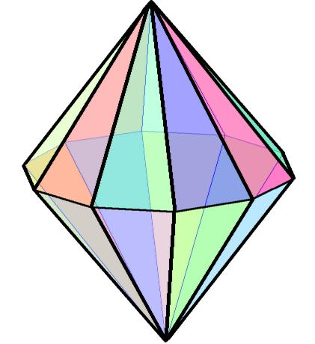

Simple Definition
# Source: AI Source: Provided by: [Data Path: Persons Table -> ID Column: 1, Name_En Column: Motasem Essam] -> From: [ChatGPT] on [7/25/2026]
A decagonal bipyramid is a solid made by joining two decagonal pyramids base-to-base, creating a polyhedron with 20 triangular faces, 30 edges, and 12 vertices.

Geometric Structure
# Source: AI Source: Provided by: [Data Path: Persons Table -> ID Column: 1, Name_En Column: Motasem Essam] -> From: [ChatGPT] on [7/25/2026]
The decagonal bipyramid has three main structural components:
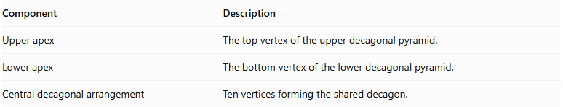
Component | Description
Upper apex | The top vertex of the upper decagonal pyramid.
Lower apex | The bottom vertex of the lower decagonal pyramid.
Central decagonal arrangement | Ten vertices forming the shared decagon.
Both apexes are connected to all ten vertices of the central decagon.

Face Structure
# Source: AI Source: Provided by: [Data Path: Persons Table -> ID Column: 1, Name_En Column: Motasem Essam] -> From: [ChatGPT] on [7/25/2026]
A decagonal bipyramid has 20 external triangular faces.
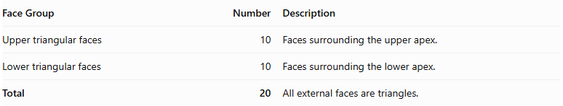
Face Group | Number | Description
Upper triangular faces | 10 | Faces surrounding the upper apex.
Lower triangular faces | 10 | Faces surrounding the lower apex.
Total | 20 | All external faces are triangles.
The common decagonal base is internal, so it is not counted as an external face.

Edge Structure
# Source: AI Source: Provided by: [Data Path: Persons Table -> ID Column: 1, Name_En Column: Motasem Essam] -> From: [ChatGPT] on [7/25/2026]
The solid has 30 edges, divided into three groups:
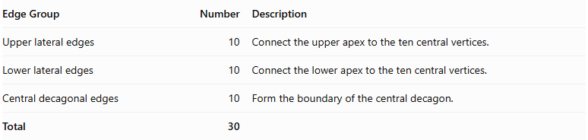
Edge Group | Number | Description
Upper lateral edges | 10 | Connect the upper apex to the ten central vertices.
Lower lateral edges | 10 | Connect the lower apex to the ten central vertices.
Central decagonal edges | 10 | Form the boundary of the central decagon.
Total | 30

Vertex Structure
# Source: AI Source: Provided by: [Data Path: Persons Table -> ID Column: 1, Name_En Column: Motasem Essam] -> From: [ChatGPT] on [7/25/2026]
A decagonal bipyramid has 12 vertices.
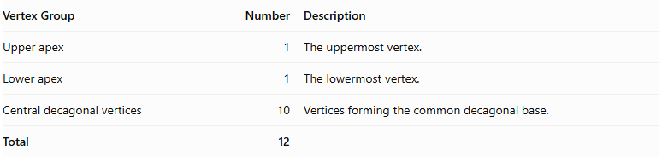
Vertex Group | Number | Description
Upper apex | 1 | The uppermost vertex.
Lower apex | 1 | The lowermost vertex.
Central decagonal vertices | 10 | Vertices forming the common decagonal base.
Total | 12

Mathematical Properties
# Source: AI Source: Provided by: [Data Path: Persons Table -> ID Column: 1, Name_En Column: Motasem Essam] -> From: [ChatGPT] on [7/25/2026]
For a decagonal bipyramid:
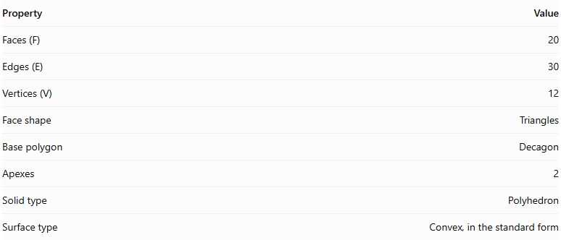
Property | Value
Faces (F) | 20
Edges (E) | 30
Vertices (V) | 12
Face shape | Triangles
Base polygon | Decagon
Apexes | 2
Solid type | Polyhedron
Surface type | Convex, in the standard form
It satisfies Euler's polyhedron formula:
$$V-E+F=2$$
$$12-30+20=2$$

Face Incidence
# Source: AI Source: Provided by: [Data Path: Persons Table -> ID Column: 1, Name_En Column: Motasem Essam] -> From: [ChatGPT] on [7/25/2026]
In the standard decagonal bipyramid:
- Each apex is shared by 10 triangular faces.
- Each central decagonal vertex is shared by 4 triangular faces.

Surface Area and Volume

Surface Area
# Source: AI Source: Provided by: [Data Path: Persons Table -> ID Column: 1, Name_En Column: Motasem Essam] -> From: [ChatGPT] on [7/25/2026]
The total surface area is the sum of the areas of the twenty external triangular faces.
$$SA=10A_{u}+10A_{l}$$
Where:
- $A_{u}$ = area of one upper triangular face.
- $A_{l}$ = area of one lower triangular face.
If the upper and lower pyramids are congruent:
$$SA=20A_{t}$$
For a decagonal bipyramid with identical triangular faces, where each triangle has base side length $s$ and slant height $l$:
$$SA=20(\frac{1}{2}sl)$$
$$\boxed{SA=10sl}$$

Volume
# Source: AI Source: Provided by: [Data Path: Persons Table -> ID Column: 1, Name_En Column: Motasem Essam] -> From: [ChatGPT] on [7/25/2026]
The volume is the sum of the volumes of the two decagonal pyramids.
$$V=\frac{1}{3}{Bh}_{u}+\frac{1}{3}{Bh}_{l}$$
Therefore:
$$\boxed{V=\frac{1}{3}B(h_{u}+h_{l})}$$
Where:
- $B$ = area of the common decagonal base.
- $h_{u}$ = height of the upper pyramid.
- $h_{l}$ = height of the lower pyramid.
For a regular decagonal base with side length $s$:
$$B=\frac{10s^{2}}{4tan(π/10)}$$
Therefore:
$$\boxed{V=\frac{5s^{2}}{6tan(π/10)}(h_{u}+h_{l})}$$

Symmetry
# Source: AI Source: Provided by: [Data Path: Persons Table -> ID Column: 1, Name_En Column: Motasem Essam] -> From: [ChatGPT] on [7/25/2026]
A regular decagonal bipyramid with congruent upper and lower pyramids has the following symmetries:
- Tenfold rotational symmetry: Rotation by ${36}^{∘}$ around the central axis maps the solid onto itself.
- Vertical reflection planes: Ten planes pass through the central axis and the central decagonal arrangement.
- Horizontal reflection plane: The central decagonal plane reflects the upper half onto the lower half.
- Central inversion symmetry: Each point has a corresponding opposite point through the solid's center.
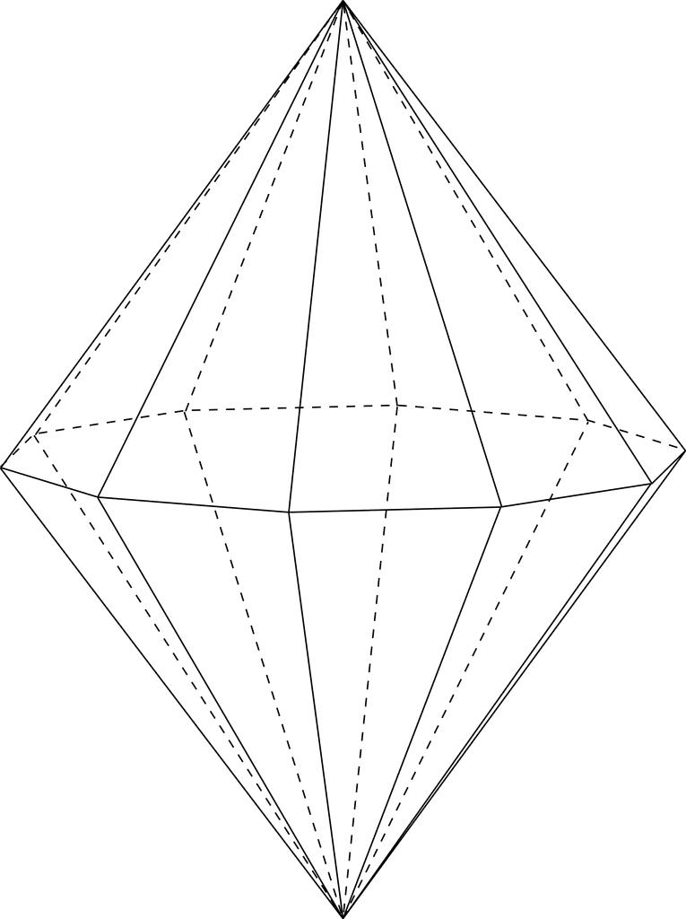

Relationship to Other Solids
# Source: AI Source: Provided by: [Data Path: Persons Table -> ID Column: 1, Name_En Column: Motasem Essam] -> From: [ChatGPT] on [7/25/2026]
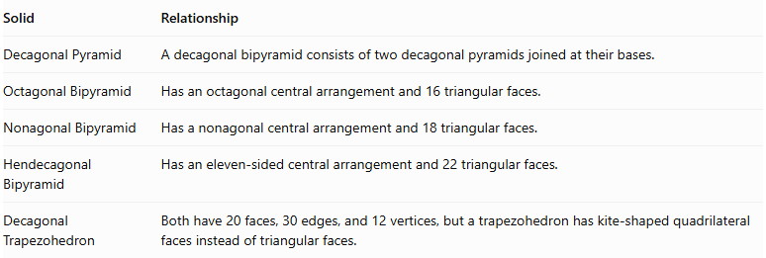
Solid | Relationship
Decagonal Pyramid | A decagonal bipyramid consists of two decagonal pyramids joined at their bases.
Octagonal Bipyramid | Has an octagonal central arrangement and 16 triangular faces.
Nonagonal Bipyramid | Has a nonagonal central arrangement and 18 triangular faces.
Hendecagonal Bipyramid | Has an eleven-sided central arrangement and 22 triangular faces.
Decagonal Trapezohedron | Both have 20 faces, 30 edges, and 12 vertices, but a trapezohedron has kite-shaped quadrilateral faces instead of triangular faces.

Worked Examples

Example 1: Calculate the Number of Faces, Edges, and Vertices
# Source: AI Source: Provided by: [Data Path: Persons Table -> ID Column: 1, Name_En Column: Motasem Essam] -> From: [ChatGPT] on [7/25/2026]
Given: A decagonal bipyramid has a decagonal central arrangement.
For an $n$-gonal bipyramid:
$$F=2n, E=3n, V=n+2$$
Since $n=10$:
$$F=2(10)=20$$
$$E=3(10)=30$$
$$V=10+2=12$$
Answer:
- Faces = 20
- Edges = 30
- Vertices = 12

Example 2: Calculate the Volume
# Source: AI Source: Provided by: [Data Path: Persons Table -> ID Column: 1, Name_En Column: Motasem Essam] -> From: [ChatGPT] on [7/25/2026]
Given:
- Area of the decagonal base: $B=150{ cm}^{2}$
- Upper pyramid height: $h_{u}=14 cm$
- Lower pyramid height: $h_{l}=11 cm$
Using:
$$V=\frac{1}{3}B(h_{u}+h_{l})$$
Substitute:
$$V=\frac{1}{3}(150)(14+11)$$
$$V=\frac{3750}{3}$$
$$\boxed{V=1250{ cm}^{3}}$$

Constructing Decagonal Bipyramid in Solid Geometry

Geometric Instruments Used
# Source: AI Source: Provided by: [Data Path: Persons Table -> ID Column: 1, Name_En Column: Motasem Essam] -> From: [ChatGPT] on [7/25/2026]
The construction uses traditional geometric instruments rather than coordinate-based construction.
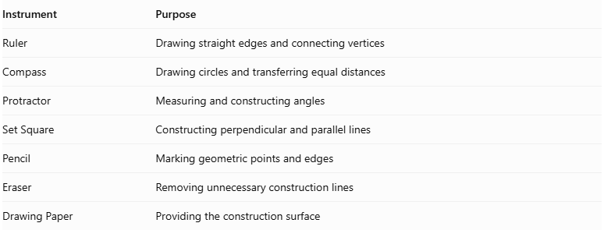
Instrument | Purpose
Ruler | Drawing straight edges and connecting vertices
Compass | Drawing circles and transferring equal distances
Protractor | Measuring and constructing angles
Set Square | Constructing perpendicular and parallel lines
Pencil | Marking geometric points and edges
Eraser | Removing unnecessary construction lines
Drawing Paper | Providing the construction surface

Instrument-Based Construction Procedures

Constructing the Decagonal Base
# Source: AI Source: Provided by: [Data Path: Persons Table -> ID Column: 1, Name_En Column: Motasem Essam] -> From: [ChatGPT] on [7/25/2026]
- Draw a circle using a compass.
- Mark the center of the circle.
- Divide the circle into ten equal angular sections using a protractor.
- Each central angle measures:
$$\frac{{360}^{∘}}{10}={36}^{∘}$$
- Mark the ten points around the circumference.
- Connect consecutive points using a ruler.
- Complete the regular decagonal base.

Constructing the First Pyramid
# Source: AI Source: Provided by: [Data Path: Persons Table -> ID Column: 1, Name_En Column: Motasem Essam] -> From: [ChatGPT] on [7/25/2026]
- Identify the center of the decagonal base.
- Construct a perpendicular line passing through the center of the base.
- Mark the first apex above the base plane.
- Connect the apex to all ten vertices of the decagon.
- Form ten triangular lateral faces.

Constructing the Second Pyramid
# Source: AI Source: Provided by: [Data Path: Persons Table -> ID Column: 1, Name_En Column: Motasem Essam] -> From: [ChatGPT] on [7/25/2026]
- Extend the perpendicular axis through the base plane in the opposite direction.
- Mark the second apex below the base plane.
- Connect the second apex to all ten vertices of the decagon.
- Form another ten triangular lateral faces.

Completing the Bipyramid
# Source: AI Source: Provided by: [Data Path: Persons Table -> ID Column: 1, Name_En Column: Motasem Essam] -> From: [ChatGPT] on [7/25/2026]
- Check that both pyramids share the same decagonal base.
- Ensure that the two apices are on opposite sides of the base plane.
- Darken the visible external edges.
- Represent hidden edges using dashed lines when necessary.
- Remove unnecessary construction marks.

Key Points
# Source: AI Source: Provided by: [Data Path: Persons Table -> ID Column: 1, Name_En Column: Motasem Essam] -> From: [ChatGPT] on [7/25/2026]
- A decagonal bipyramid is formed by joining two decagonal pyramids at their bases.
- It has 20 external triangular faces.
- It has 30 edges.
- It has 12 vertices.
- Its common decagonal base is internal and is not counted as an external face.
- Its volume is the sum of the volumes of the two decagonal pyramids.
- A regular symmetric decagonal bipyramid has tenfold rotational symmetry.

Conclusion
# Source: AI Source: Provided by: [Data Path: Persons Table -> ID Column: 1, Name_En Column: Motasem Essam] -> From: [ChatGPT] on [7/25/2026]
The Decagonal Bipyramid is a polyhedron formed by combining two decagonal pyramids around a shared decagonal base. It belongs to the family of $n$-gonal bipyramids and has 20 triangular faces, 30 edges, and 12 vertices.
Its defining characteristic is the ten-sided central arrangement connecting the upper and lower apexes.

